Final Year Project Report
SMART HOME ENERGY OPTIMIZATION USING IOT AND AARTIFICIAL INTELLIGENECE AND MACHINE LEARNING: A COS EFFECTIVE NILM SOLUTION

Project Advisor:

Submitted By:
Muhammad Salman f2022266223
Abdul Wahid Khan f2022266604
Ubaid Ahmed f2022266825
Sajjad Ali f2022266891

Session
2022-2026

University of Management and Technology
C-II Johar Town Lahore Pakistan

Dedication
The book is dedicated to people who were behind the scenes. To my parents. You were not aware of the code errors or ESP32 crash causes but you knew. my face when I was tired. You brought food. You prayed. That was enough.
To my friends and team. We argued. A lot. Until we wanted to agonize we did. to quit. But we didn't. We sat in the laboratory, and stranded the wiring and laughed when it finally. worked. It does not just have technology with this project. Our patientia, in paper-letter.
And to Sir Ammar Yasir Sajjad. You did not accept the version of the facile. You pushed us to be professionals. Thank you for that pressure.

Final Approval

- Head of Department ______________________
Department of Informatics & Systems
School of Systems & Technology
UMT Lahore

- Director (Final Year Projects-CS) ______________________
Department of Computer Science.
School of Systems & Technology
UMT Lahore

- Supervisor ______________________
- Department of Informatics & Systems.
- School of Systems & Technology
UMT Lahore
- Co-Supervisor ______________________

Acknowledgment

To begin with, I want to thank Allah Almighty. A complicated system such as this Smart Energy Monitor would not have been possible without the blessings of Him. He provided me with time to spend hours before a screen debugging code.
I would like to thank our supervisor on the project, Sir Ammar Yasir Sajjad. He really pushed us. We have reached points where we believed that the NILM algorithms cannot be applied to the ESP32 S3 but he directed us on how to resolve the issue. His comments regarding the sensor accuracy were severe. He did not simply accept mediocre work, he had us seek to perfect it to the point of it being professional.
Great credit to the Department of Computer science. They provided the means and the setting of the laboratory. Knowing how to deal with high-voltage equipment safely was important and without their help, we would only be shooting in the dark.
I also need to thank my family. The prayers, the cash to give me these hardware components, and the tea that came to see me when I was stuck on a code bug at 3 AM. It was the trifles that kept me alive.
Lastly, thanks to my team. We learned a lot together. We had bugs, we had difficulties with integrating React Native and we did solve the circuit issue somewhere. It has not been a smooth ride and we made it to the finish line.

Project Title
SMART HOME ENERGY OPTIMIZATION USING IOT, TINYML, ARTIFICIAL INTELLIGENCE, MACHINE LEARNING AND NILM-BASED EDGE INTELLIGENCE.

Objective
To develop a localized, privacy-centric smart energy system utilizing manual TinyML for Non-Intrusive Load Monitoring to identify individual appliances, detect power leakage anomalies, and forecast electricity bills via mobile app without cloud dependency.

Undertaken by

Supervised by
Starting Date

Completion Date

Tools Used
( C++, React Native, FreeRTOS, TensorFlow Lite Micro, Google Colab and SMOTE, Arduino IDE, VS Code/Antigravity.)

Operating System Windows 10 / 11
Documentation Microsoft Word / Google Docs

Plagairism Report
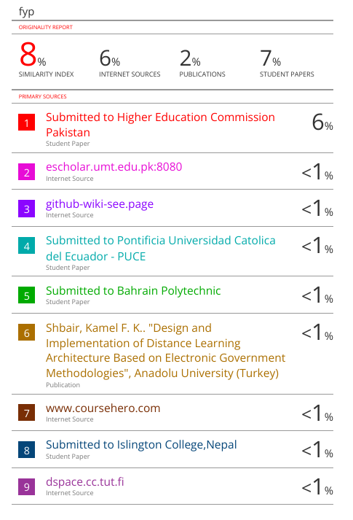
Abstract(Anticipated)
Energy consumption in our homes is invisible. Totally blind. You have electricity flowing to every room, but no idea where it is going. The utility meter just gives a total number at the month end. It doesn't tell you if the Fan ran too long, or if hidden power leakage occurred behind the sockets. This confusion causes "bill shock" and really hurts the family budget. We saw this problem and decided to build the Smart Home Energy Optimization System, a localized IoT solution to fix this blind spot.
It is a loop where monitoring and control by the user are integrated. However, we did not desire a dull smart meter which merely spills out numbers. Our desire was to have people knowing how to save. Therefore, we included Intelligent Forecasting. The React Native app contains a predictive engine using Linear Regression, which predicts the WAPDA bill in real-time. It transforms a threatening shock into an attainable goal, motivating users to save more.
The construction is designed around the ESP32-S3 microcontroller using dual-core OS threads and 40-byte memory-optimized Structs for SD block storage. It does processing on-site. A custom C++ Tiny ML model, trained manually on SMOTE-augmented data, performs NILM (Non-Intrusive Load Monitoring) to automatically identify appliances. Concurrently, it detects continuous power leakage anomalies.
Geared towards a 30 percent energy saving, this project serves Pakistani families who detest huge bills and invasion of privacy. It fills the gap between basic setups and commercial monitors, converting a blinding payment into complete contro
Revision Chart

Version | Primary Author(s) | Description of Version | Date Completed

Contents
Contents 1
Definitions and Acronyms 3
List of Figures 4
List of Tables 5
1. Introduction 6
1.1 Motivations 6
1.2 Project Overview 6
1.3 Problem Statement 6
1.4 Objectives 6
2. Domain Analysis 7
2.1 Customer 7
2.2 Stakeholders 7
2.3 Affected Groups with social or economic impact 7
2.4 Dependencies/ External Systems 7
2.5 Reference Documents 7
2.5.1 Related Projects 7
2.5.2 Feature Comparison 8
3. Requirements analysis 9
3.1 Requirements 9
3.2 List of Actors 10
3.3 List of use cases 10
3.4 System use case diagram 10
3.5 Extended use cases 10
3.6 User interfaces (mock screens) 12
4. Data flow diagram (optional) 13
4.1 Data Flow Diagram Level 0 13
4.2 Data Flow Diagram Level 1 13
4.3 Data Flow Diagram Level 2 13
5. System Design 15
5.1 System Architecture Diagram 15
5.2 Class Diagram 16
5.3 Collaboration Diagrams 17
5.4 Other UMLs 18
5.5 ERD 18
5.6 Data Dictionary 18

LIST OF FIGURES :

Figure 1:System use case diagram 21
Figure 2:DATA FLOW DIAGRAM LEVEL 0 25
Figure 3:Data flow diagram level 1 26
Figure 4:DATA FLOW DIAGRAM LEVEL 2 27
Figure 5:SYSTEM ARCHITECTURE DESIGN 28
Figure 6: System Architecture 29
Figure 7:CLASS DIAGRAM 29
Figure 8:SEQUENCE DIAGRAM 30
Figure 9:COLLABORATION DIAGRAM 31
Figure 10: Other UMLs (Sequence Diagram) 31
Figure 11:ERD DIAGRAM 31
Figure 12:ERD DIAGRAM EXTENDED 32

List of Tables:

Table 1: table of acronyms and definitions 3
Table 2:Stakeholders 9
Table 3: list of stakeholders 10
Table 4:feature comparison: 13
Table 5:Functional categories 16
Table 6:Requirement List 16
Table 7 18

Introduction
The concept of Smart Energy Optimization was not taught in a book. It came from bill shock. We visited the houses of today and found a huge issue. Everything is quick and intelligent, yet, somehow, energy monitoring is nonetheless stupid. The utility meter is viewed as the evil creature that only comes to collect cash. The wiring is further still worse where the consumption is buried behind the walls. Why not make a change of that, we thought? We wanted to create something that reminds us of a brain to the house. One sensor. One truth . One sensor. One truth .
It is all of it that our system bring together. It works with the complicated stuff such as voltage and current, but it does it smartly. To explain, in the case of the Fan that is on and the room is hot, the system utilizes AI reasoning to work out the error the instant. There is no need that any human being take action manually to check the temperature. Yet we desired that it should be confidential. Studies indicate that individuals detest spyware cloud devices on them.. So, we put the brain inside the chip, offline. It sounds hard, but it works. Users log in to check the bill, and while they are there, they see exactly which device is eating money. It turns a monthly shock into a daily habit. This project is about removing the friction between the homeowner and their switchboard.

Definitions and Acronyms
Acronym | Definition
FYP | Final Year Project
EOS | Energy Optimization System
NILM | Non-Intrusive Load Monitoring
Tiny ML | Tiny Machine Learning
RMS | Root Mean Square
PZEM | Peacefair Zone Energy Monitor
CSV | Comma Separated Values
KWh | Kilowatt Hour
Table 1: table of acronyms and definitions

Motivations
The idea for Smart Energy Optimization came from a simple but frustrating reality. Electricity prices are rising, fast, and somehow we are still blind. Energy consumption often walk hand in hand with confusion. It happen in almost every Pakistani home. Consumption data rarely lives in our hands. Instead, it is hidden. Meter reader comes once a month. Then bill arrive. AC usage here. Iron usage there. Which one cause the spike? Nobody knows. It feels messy, because it is.
This blindness create problems. Too much wastage. Requesting expensive phantom loads. Money did go down the things that should. Month after month the domestic budget dies away month. Next, there is commercial Smart Meters. The so-called wise approach. The ironical thing is that the section happens to be the least accessible most of the times. Some solutions are perceived in Sonoff among others in the market not easily installed and expensive. They are not purchased on a regular basis but when the people have some spare cash. No one fit independent plug to all sockets at will. Due to that reason, the saving of energy is not considered.
Wiring stays old. Bills stay high. There is however something interesting that research tells us. Real-time feedback works. When users see live data, they pay attention. They save more. Details, red, minor details alerts--can change behavior. Migrating can even occur to the simplest mobile application that is connected to a local Wi-Fi how domestic attitude to electricity. It is simply a matter of a switchboard. It is a place people can control. It was our desire to have such control. Without the high cost.

Project Overview
The Smart Home Energy Optimization system is a robust, offline IoT network designed to manage a household's entire energy lifecycle. Acting as the master controller of the house, all electrical parameters—Power, Current, and Voltage—flow through it. One device. One truth. No confusion.
The project is divided into several core modules, each solving real-world billing problems.
Real-Time Monitoring tracks the active load and consumption. The system uses a custom Tiny ML model (manually trained via Google Colab using SMOTE data augmentation) running entirely in pure C++ on the ESP32-S3 to identify specific appliances. A React Native mobile app provides a digital dashboard displaying live graphs and remaining budgets instantly, eliminating bill shock.
Bill Forecasting ensures highly accurate cost predictions. Instead of burdening the microcontroller, the React Native app executes the Linear Regression algorithms. It calculates the estimated month-end cost by integrating daily usage with local WAPDA tariff slabs, preventing users from spending excessively.
Power Leakage Detection runs continuously in the background utilizing OS Threads on Core 1. It employs specific logic to detect hidden energy waste. If the AI model identifies no active appliance, but the sensor detects a power draw greater than 10W, the system immediately flags a Power Leakage anomaly.
Data Logging (Offline Storage) adds a secure, privacy-centric layer. The device utilizes memory-optimized 40-byte Structs to save raw telemetry directly into the SD Card using Block Storage. This allows users to export and analyze their history locally, turning raw numbers into actionable insights without internet dependency.
Sample Artifacts
The system is designed for common Pakistani households and mid-sized families. Its main goals are to cut electricity bill by 30% and increase energy awareness. Core system features include automated appliance recognition, bill prediction, anomaly detection, and offline logging that encourage saving and safety.

Problem Statement
The use of dumb energy meters continues to be used in many Pakistani families to control the use of electricity. Nothing talks to us. The meter stand in the wall outside. The appliances are used within the rooms. This disconnect cause disorientation, shock of bills and wasteful expenditures.
Electricity bills tend to be unreasonable or inexplicable. Personal, families rely on memory speculations, or screaming at children instead of facts. No direct relationship of how long the AC run and calculation of the bill. Consequently, it makes saving activities pointless and inconsistent. We don't know who the thief is.
Another big source of pain is the identification of power hogs. Getting cost of particular device. It is impossible to do manually like Iron or Motor. The user has to guess by time, yet phantom loads--gadgets which stand by--are a killer of mathematics. This causes high bills and we even pay electricity that we did not even utilize.
There is also a low rate of energy awareness. The majority of individuals do not pay much attention to the meter reading. Critical warnings like voltage variability or leakage of AC gas are not realized until it is too late equipment burns out. The meter ceases to be a tool over the course of time and turns out to be another ignored box.
Financially, it has low levels of transparency. In the absence of a clever program such as "Bill Forecast," families are not doing good tracking real-time budget. The decision-making is reactive following the bill arrive instead of proactive. As well, the current smart plugs are too costly and also encroaching on privacy by sending data to cloud.
The problem itself is quite basic yet very grave in essence as households do not have one, offline, house efficient, automated and intelligent energy management system. This gap burns money, puts safety at a risk, and undermines overall effectiveness.

Objectives
The primary objective of the Smart Energy Optimization system is to consolidate monitoring into a compact enclosure. No more scattered wires or guesswork. The ESP32-S3 microcontroller processes Voltage, Current, and AI algorithms locally, reducing hardware costs and minimizing physical mess. One device. One truth.
Another vital objective is the automated detection of appliances via NILM. The system analyzes spikes in raw current data, eliminating noise to run inferences through a custom-trained C++ TinyML model (built manually via Google Colab). This allows appliances to be identified automatically without cloud dependency, preventing unidentified high utility bills.
The project also aims to make energy conservation engaging. Instead of a dull meter on a wall, it introduces a React Native mobile app featuring real-time Linear Regression forecasting and live consumption graphs. The core idea is simple: make users feel in control and aware of their switchboard. Tech meets savings.
The final priority is the enhancement of safety through a logic-based fault detector. Instead of using complex multi-sensor fusion, the system relies strictly on continuous power data to detect anomalies. If an unidentified load exceeds 10W, the system immediately flags a Power Leakage alert, enabling proactive judgments before electricity bills cross budget limits.

Customer
The primary users of this project are typical Pakistani families, particularly those utilizing multiple heavy appliances such as Air Conditioners, refrigerators, and water motors. Each device has a unique power consumption pattern that requires precise tracking, making household financial monitoring far more complex than a standard utility meter portrays.
The system is built around the real-life requirements of a middle-income household relying on a strict monthly electricity budget. These users demand accuracy, transparency, safety, and above all, privacy. In these homes, consumption is entirely decentralized—the AC runs upstairs while the fridge hums downstairs, with all electrical activity completely concealed behind the walls.
Due to this "blind" usage, a locally-based, intelligent solution is not just an option, but a necessity. The hardware is designed specifically for single-phase residential grids to monitor the aggregate load. By processing the AI data strictly offline via the ESP32-S3 and transmitting it over local Wi-Fi to a React Native mobile app, the system brings hidden consumption out of the wires and directly onto the user's phone screen, all without ever sending private data to cloud servers.

Stakeholders
The following table identifies the key stakeholders and their interaction with the system
Table 2:Stakeholders
Stakeholder | Role in System
Homeowner  (Admin) | The Homeowner holds absolute administrative control over the system. They manage the budgetary parameters and oversee major operations directly through the mobile application. Their primary responsibilities include utilizing the Bill Forecasting module, configuring safety voltage limits, and manually triggering the relay override when necessary. As the main financial decision-maker of the household, they actively monitor usage patterns and control power distribution to maximize cost savings.
Family Members | Family members are the primary consumers of electricity and interact with the system on a daily basis. Their main responsibilities include monitoring appliance usage via the "Live Graph" on the mobile app and responding to real-time alerts, such as Power Leakage notifications. By adjusting their usage habits based on these system warnings, they actively help reduce the monthly bill. They are both contributors to the household power load and direct beneficiaries of the optimization platform.
System Administrator (Dev) | The System Administrator manages the backend technical infrastructure. They are responsible for calibrating the PZEM sensor and ensuring that data is correctly logged to the SD card using memory-optimized 40-byte Structs. They handle the ESP32-S3 C++ firmware updates. If the NILM model misidentifies an appliance, the administrator is responsible for manually retraining the model using Google Colab and SMOTE data augmentation, converting it to a C++ header file, and flashing the updated firmware to ensure accurate and safe operation.
Utility Provider | The Utility Provider (such as WAPDA) serves as the external standard for this project. Although they do not interact with the system directly, their official tariff slabs and tax structures dictate the pricing logic integrated into the React Native app's forecasting engine. The actual bill they issue at the end of the month acts as the benchmark to validate the accuracy of our system's predictive calculations. Additionally, the system accounts for their grid power supply schedules to maintain accurate, continuous offline monitoring.

Table 3: list of stakeholders
Family Members: Family members will experience a positive social impact through the real-time feedback system. Live consumption graphs and threshold alerts on the mobile app increase energy awareness and promote efficient habits. Clear metrics—such as daily cost, appliance status, and active load—help them understand exactly where to save. Furthermore, the anomaly detection feature provides peace of mind by immediately identifying hidden Power Leakage, preventing unseen wastage and encouraging safe appliance usage.
Homeowner (Admin): The homeowner will benefit primarily on an economic and operational level. Automated bill prediction (powered by Linear Regression within the React Native app) and automated Power Leakage detection significantly reduce financial stress. Live cost and usage dashboards empower the head of the family to make proactive budget decisions and address abnormal power drains long before the official WAPDA bill arrives. This facilitates smarter, proactive financial management.
Utility Grid / Environment: The external environment will benefit from reduced overall energy wastage. Decreased demand at the household level ensures the National Grid faces less pressure, potentially increasing grid stability and reducing load-shedding hours. Efficient residential consumption also shrinks the overall carbon footprint, allowing utility companies to distribute energy more equitably.
Local Community: The financial barrier to entry for middle-class families is significantly lowered by the system's low-cost, offline ESP32-S3 architecture. By replacing expensive, cloud-dependent commercial smart plugs with a singular, privacy-centric monitoring device, more households can afford smart energy tracking. This enhances both national energy literacy and cumulative economic savings.

Dependencies/ External Systems

The Smart Energy Optimization system relies on several external systems and hardware components to function smoothly. These dependencies play a critical role in operating the project effectively:
Local Wi-Fi Network: > The system depends on a local Wi-Fi router for connectivity. Even though the architecture is strictly privacy-focused and completely offline (no Cloud servers), the ESP32-S3 requires a local network link to transmit telemetry to the mobile app. Without this, the real-time "Live Graph" feature will not function, and users would have to extract the SD card to check logs manually. It serves as the secure local bridge between the sensor and the phone.
Google Colab & TensorFlow Lite Micro: > To identify appliances intelligently, the project relies on Google Colab for manual model training and SMOTE (K=3) for data augmentation. Once trained, the model is converted into a pure C++ header file using TensorFlow Lite Micro. This dependency is crucial for executing the NILM inference and Power Leakage detection directly on the ESP32 chip without ever sending data to the internet. (Note: Edge Impulse has been completely removed from this workflow).
Mobile Device (Android): > The user interface and secondary calculations depend on modern smartphone capabilities. It requires an Android device to install the React Native app. Because the app's internal logic handles the heavy Linear Regression forecasting and WAPDA slab calculations, older phones lacking adequate processing speed may struggle to render the real-time graphs smoothly. The phone acts as the intelligent display screen for our headless hardware.
Stable Power Supply: > The system depends on the main grid voltage to remain operational. The PZEM sensor and ESP32-S3 require a stable current to measure electrical parameters accurately. If the grid power goes out completely, the system stops monitoring. We rely on the main electrical phase to keep the "brain" of the house running seamlessly.

Reference Documents
Several documents and resources were reviewed during the analysis phase of the Smart Energy Optimization project. These sources provided the technical foundation for integrating the hardware components and developing the software architecture properly.
Smart Home System Requirements: This served as the primary functional point of reference. It explained how hardware devices—such as the ESP32-S3, PZEM sensor, and Relays—must behave within an offline IoT ecosystem. It heavily influenced our circuit-level design choices and safety protocols.
Espressif & TensorFlow Lite Micro Documentation: Official documentation was utilized to deploy complex code onto the microcontroller. The Espressif guides provided crucial support for implementing FreeRTOS dual-core threading (specifically utilizing Core 1 for real-time monitoring) and managing memory constraints using 40-byte C++ Structs. The TensorFlow Lite Micro documentation guided the manual conversion and integration of the TinyML model into a C++ header file. (Note: Edge Impulse has been completely removed from the workflow).
IEEE Research Papers on NILM: Academic literature, including “Non-Intrusive Load Monitoring Techniques for Smart Homes,” was referenced to understand signal disaggregation. These papers explained the mathematical models required to identify individual appliances from a single main wire without deploying distributed sensors, which directly informed our manual Google Colab training and SMOTE data augmentation strategies.
Fritzing & Draw.io Guides: These tools were used to accurately design the wiring diagrams. They supported the creation of the circuit schematics, system architecture, and logic flowcharts included throughout the design phase of this documentation.

Related Projects
To design and develop the Smart Energy Optimization system, several existing market solutions and hardware architectures were analyzed. This comparative study helped identify critical market flaws, highlight technological gaps, and shape our localized, privacy-centric, and highly affordable solution.
1. Standard Digital Meters (WAPDA / LESCO): > Standard digital meters are the default devices installed outside Pakistani homes. While they provide rugged reliability and baseline accuracy for total monthly billing, they are fundamentally "dumb." They offer zero disaggregation—meaning they cannot identify which specific appliance consumed the electricity. There is no real-time display, and consumption data is completely hidden until the month-end bill arrives. Our system resolves this blind spot by providing continuous live feedback, instant Power Leakage alerts, and real-time cost analysis directly on the user's mobile phone. (Reference: Local Utility Standards)
2. Commercial Smart Wi-Fi Plugs (Sonoff / Tuya): > Sonoff and Tuya are popular distributed IoT plugs used for home automation. While effective for basic remote ON/OFF control, they suffer from critical scalability flaws. First, requiring a separate smart plug for every single socket is prohibitively expensive for a middle-class household. Second, their architecture is entirely cloud-dependent; if the internet goes down, monitoring and control are lost. Furthermore, transmitting continuous household telemetry to third-party overseas servers poses a severe privacy risk. In contrast, our solution utilizes a single, centralized sensor to monitor the entire house, processing all data strictly offline. (Reference: sonoff.tech)
3. Sense Home Energy Monitor: > Sense is a premium, commercially available product that utilizes NILM (Non-Intrusive Load Monitoring) technology. While highly capable of identifying individual appliances, it is entirely unsuited for the Pakistani domestic market due to its exorbitant cost ($300+). Additionally, it requires complex installation within the main breaker panel and is engineered for stable US grid voltages, often struggling with the severe voltage fluctuations common in local grids. Our project democratizes this advanced NILM capability by executing it on a low-cost, locally robust ESP32-S3 microcontroller using custom TinyML models, making it both affordable and resilient. (Reference: sense.com)

Feature Comparison
Table 4:feature comparison:
Sr no | Comparison Feature | Standard Digital Meter | Smart Wi-Fi Plugs (Sonoff) | Smart Energy System (FYP) | Remarks
1 | Real-time Monitoring | S No (Monthly Only) | Yes (Per Socket) | Yes (Whole House) | Our system show live graph on phone. Standard meter only show total unit on LCD.
2 | Appliance Recogniti-on | None | None (Hardwired) | AI Based (NILM) | Smart plugs needs separate device for every switch. We identify appliance from main wire using TinyML.
3 | Bill Forecasting | None | Basic (Usage x Rate) | Intelligent (Regression) | Uniquely predicts the month-end bill based on history to prevent "Bill Shock" before it happens.
4 | Data Privacy | N/A | Low (Cloud Based) | High (Offline SD Card) | Commercial plugs sends data to China/Cloud. We keep data inside house on SD card. No internet spying..
5 | P Fault Detection | Fuse Only | Overload Cut | Logic Based (Sensor Fusion) | Uses specific logic: If Power is High + Temp is High -> Trip Relay. Checks if AC is actually cooling.

Requirements analysis

Requirements
The requirements is categorized into Functional (FR), Non-Functional (NFR), and Domain Requirements (DR). These are derived directly from the 'Smart Home System Specs' and standard IoT practices.
Functional Categories:
Table 5:Functional categories
Category | Description
Functional Requirements (FR) | Core services requested by the user (e.g., View Live Graph, Detect Appliance, Forecast Bill). It tells what system do.
Non-Functional Requirements (NFR) | Supporting requirements that define quality attributes (e.g., Sensor Accuracy, App Response Time, Offline Capability). It tells how well system work.
Data Requirements (DAR) | Requirements regarding storage, logging format, and retention of data on SD Card. We need to save history even if Wi-Fi is down.
Domain Requirements (DR) | Physics rules specific to electricity (e.g., Ohm's Law, WAPDA Tariff logic, Voltage thresholds). These are rules we cannot change.
Constraints | Limitations imposed by hardware or budget (e.g., Low Memory of ESP32, Single Phase only, No Cloud Database).
External Interface Requirements | Requirements for connecting wires to PZEM sensor and sending data to Android App via local Wi-Fi.

Requirements List:
Table 6:Requirement List
RID | Description | Category | Attribute | Details & Boundary Constraints
R1.1 | System must verify sensor connection on boot | FR | Reliability | ESP32 must check PZEM status before starting loopt
R1.2 | App dashboard must display live Voltage & Current | FR | Performance | Data update must happen in less than 1 second
R1.3 | System must prevent logging if SD Card is missing | DR | Data Integrity | "Mount Failure" check required to avoid crash
R1.4 | System must identify appliance using NILM logic | FR | Intelligence | Recognition only if probability score > 80%
R1.5 | Forecasting module must check "Budget Limit" | DR | Consistency | Default budget is 5000 PKR (configurable)
R1.6 | System must generate System must generate CSV files for energy logs | FR | Compatibility | File format must be readable by Excel/PC
R1.7 | User must be able to set Voltage Trip limits | FR | Functionality | Upper limit cannot be lower than Lower limit
R2.1 | R App must separate Admin and Guest views | NFR | Security | Admin need PIN code to change relay settings
R2.2 | Live Graph must render without freezing phone | NFR | Usability | React Native bridge must handle rapid data
R2.3 | System must auto-trip relay during overload | FR | Safety | Response time must be under 500ms to save device
R3.1 | Monthly Bill must be calculated using Tariff slabs | DR | Accuracy | Logic must handle 1-100 unit rate vs 300+ unit rate

Table 7
Req id | Requirement Description | Module Covering it | Status
R1.1 | Verify Sensor Connection | Hardware Init | Completed
R1.2 | Live Voltage & Current Display | App UI Module | Completed
R1.4 | Identify Appliance (NILM) | AI Inference Engine | Completed
R1.6 | Generate CSV Log Files | SD Card Service | Completed
R2.1 | Role-Based Access (Admin/User) | App Security | Completed
R3.1 | Auto-Trip Relay on Fault | Safety Control | Completed

List of Actors
Homeowner (Admin): This is the head of house. Full control. Almost too much. The Admin can access every setting—Voltage limits, Budget, Wi-Fi config. They view "Bill Forecast" reports, trip the relay manually, and decide when to cut power. Saving money? Supervised here. Nothing risky runs without them knowing.
Family Member: The most common actor. And the source of the bills. Family members turn on appliances, view live graphs, and get alerts on their phone. They can see how much cost they are wasting, but they cannot change the safety limits. They don't run the system settings. But they create the load.

Technical Support (Dev): It is greater than homeowner. He knows the code. He updates the firmware when bug is found. At the wrong direction of the readings the PZEM sensor is calibrated. He fills the hardware/app gap. Not fully owner. But he fixes the mess behind the wall.

The AI Agent (TinyML): Focused. Math-oriented. This actor is incorporated into the chip. It processes the identification of the appliances. It don't touch the relay much. That's not its space. It just screams "Fridge is ON!" or "Motor is ON!". It is more of an informational influence than informational. physical. A single misplaced guess will lead to the user going down the wrong road.

Watchdog Timer: Not an actor, but people. And a stakeholder on its side. This esp32 automatized, noisy in the background. It checks are of the system, saves. SD card recording, and restart automatically, when Wi-Fi connections are frozen. No face. No feelings. But without it, the machine would die out of business in one day.

List of use cases

User Login: This is the app that is available to the customers via local IP connection out of the neighbourhood, in the majority of cases.

Browse: allows access to real-time dashboard, voltages, currents, power and bill forecasts. In a glance the whole hideous is uncovered.

Manage settings: Lets Admin control sensors, fix Wi-Fi and voltage settings. Manageable technical resources.

View Forecast: It will enable one to see bill forecasts when the month ends and the level of usage. The predicting of real and dirty, by mathematics.

Check Logs: Check history of the past consumption can be displayed on SD card. Simple graph. Wasteness of money that is discernible.

Monitor Live Graph: It will show a user in real-time a graph of power spikes. Spikes feed into anxiety and awareness.

Set Budget: Homeowner fixed the amount of rupees that would be fixed on a month. If limit cross, system sends alert.

Identify Appliance: AI gives a guess on what the respective appliance is (e.g. Iron, Motor). Status can be monitored and traced.

Calculate Bill: System use case to automatically compute the cost in terms of WAPDA tariff slabs. Less manual math involved.

Fault Detection: Immediate signifying of overload, low or high voltage. Helps spot fire risk early.

Trip Relay: This is a mechanical power off of the phone application. Safety precedes human command.

Export Data: This will be to save the CSV file to analyze it in PC. Feeds directly into Excel for record.

System use case diagram
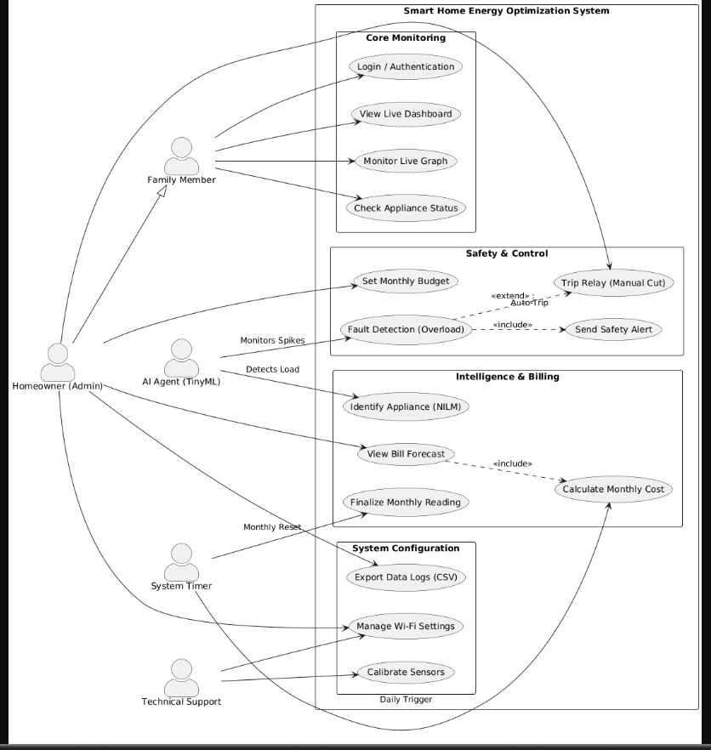
Figure 1:System use case diagram

Extended use cases
Use Case 1: Employee Login
Use Case ID: | UC-1.0
Use Case Name: | User Login (Local Access)
Created By: |  |  | Last Updated By:
Date Created: |  |  | Last Revision Date:
Actors: |  | Family Member, Admin (Homeowner)
Description: |  | Allows users to access the energy dashboard using local Wi-Fi. It keeps neighbors and outsiders out of our system.
Trigger: |  | User opens the Android App on their phone.
Preconditions: |  | 1. ESP32 device must be powered ON.  2. Phone must be connected to same Home Wi-Fi network.
Post conditions: |  | 1. User sees the Live Graph.  2. Real-time connection is established.
Normal Flow: |  | 1. User taps the App icon.  2. Ad hoc scans the local network of ESP32 IP address.  3. System is connected to the device.  4. On entering PIN code, the user is required to be the Admin.  5. System checks PIN.  6. Real-time voltage and current levels appear on the dashboard.

Alternative Flows:  [Alternative Flow 1 – Device Offline] | - ESP32 fails to send packet.  - App displays "Reconnecting..." spinner.  - Graph freezes for 5 seconds.  - An automatic linkage is made.
Exceptions: | Wi-Fi Signal Lost: If user walks too far from router, the live graph stops updating and shows "Reconnecting...".
Includes: | None. (This is starting point).
Frequency of Use: | High (Every time we want to check bill).
Special Requirements: | 1. Response time must be under 1 second.  2. PIN must be saved locally on ESP32 memory.  3. App should not crash if data packet is lost.
Assumptions: | User has already installed the APK file on phone.
Notes and Issues: | - TBD: Should we add a "Guest Mode" for visitors who just want to see the voltage? (Currently only Family or Admin).

Use Case 2: Generate Bill Report
Use Case ID: | UC-3.1
Use Case Name: | Generate Bill Report (Forecast)
Created By: |  |  | Last Updated By:
Date Created: |  |  | Last Revision Date:
Actors: |  | Primary: Homeowner (Admin)  Secondary: SD Card Module, Utility Logic
Description: |  | Automated closing of the monthly meters. It calculates total cost Moves to permanent history, and reinstates to the beginning of the next month the counter of Current Units to a zero.
Trigger: |  | User clicks the "Export Data" or "Check Forecast" button in the App.
Preconditions: |  | 1. User must be connected to ESP32 Wi-Fi.  2. SD Card must be mounted and have at least 1 day of logs.
Post conditions: |  | 1. CSV file is saved or downloaded to phone.  2. Total estimated cost is displayed on screen.  3. User knows the "Damage" done to wallet.
Normal Flow: |  | - Date System Timer (e.g. 1 st Jan).  - TotalkWh variable is read system value.  - Final Cost is calculated in System using Tariff Logic.  - The received data is inputted into SD Card: [Jan, 350 Units, 12000]. PKR].  - System notification Month ended Bill saved.  - Program sets TotalkWh to 0 at beginning of each month.
Alternative Flows:  [Alternative Flow 1 – No Storage] |  | 2a. SD Card Missing:  1. System detects no card in slot.  2. Shows error "Storage Not Found".  3. App stops the process.  [Alternative Flow 2 – Zero Usage]  5a. No Data Found:  1. User selects date where power was OFF.  2. System shows validation error "No logs found for this date".
Exceptions: |  | Write Failure SD Card on save the system on boot. the data to the working memory and tries once again an hour later. It never opposes until information is safeguarded.
Includes: |  | Check Tariff Rates (Always calculates using latest price).
Frequency of Use: |  | Medium (Once per month or week).
Special Requirements: |  | 1. Generated file must be readable by Microsoft Excel or Google Sheets.  2. Calculation must match standard single-phase meter logic.
Assumptions: |  | The user has set the correct Tariff Rate (e.g., 35 PKR/Unit) in settings.
Notes and Issues: |  | Note: Currently only supports Fixed Rate or simple Slab. Advanced "Peak/Off-Peak" time logic is future feature.

Use Case 3: Monitor Live Graph (Real-Time)
Use Case ID: | UC-4.1
Use Case Name: | Monitor Live Energy Graph
Created By: |  |  | Last Updated By:
Date Created: |  |  | Last Revision Date:
Actors: |  | Primary: Family Member  Secondary: PZEM Sensor Module
Description: |  | Allows family members to watch the live electricity consumption on phone screen. It helps to catch the "thief" appliance instantly. High spikes are shown in Red color to warn the user.
Trigger: |  | User taps the "Live Monitor" widget on the Dashboard.
Preconditions: |  | 1. User must be connected to local Wi-Fi.  2. ESP32 and Sensor must be powered ON.
Post conditions: |  | 1. Live Voltage, Current, and Power is displayed.  2. Graph updates every 1 second.
Normal Flow: |  | 1. User loads the Monitor Module.  2. App establishes WebSocket connection with ESP32.  3. User watches the line graph.  4. Someone turns on heavy appliance (e.g., Iron).  5. Graph shoots up immediately.  6. System calculates "Cost per Hour" for that load.  7. User turns off the appliance.  8. Graph goes down to normal.
Alternative Flows:  [Alternative Flow 1 – Sensor Timeout] |  | 2a. No Data Received:  1. ESP32 fails to send packet.  2. App displays "Reconnecting..." spinner.  3. Graph freezes for 5 seconds.  4. Connection resumes automatically.
Exceptions: |  | Overload Warning: If graph touches the "Max Limit" line (e.g., 10 Amps), the phone vibrates to warn the user before the Relay trips.
Includes: |  | UC-Read-Sensor-Data (Called repeatedly every second).
Frequency of Use: |  | High (Whenever AC or Motor is running).
Special Requirements: |  | 1. Graph must run smoothly without lagging the phone. 2. Must handle rapid changes in current without crashing.
Assumptions: |  | User is within the Wi-Fi range of the hardware box.
Notes and Issues: |  | Lag Issue: Sometimes if Wi-Fi signal is weak, the graph delays by 2-3 seconds. We need to optimize the code for faster speed.

Use Case 4: Finalize Monthly Reading (Reset)
Use Case ID: | UC-2.5
Use Case Name: | Finalize Monthly Reading (Reset)
Created By: |  |  | Last Updated By:
Date Created: |  |  | Last Revision Date:
Actors: |  | Primary: System Timer (RTC Module)  Secondary: Homeowner (Admin)
Description: |  | Automates the closing of the monthly meter cycle. It calculates total cost for the month, saves it to permanent history, and resets the "Current Units" counter to zero.
Trigger: |  | System Timer detects 1st of the month (00:00 AM) OR Admin clicks "Manual Reset".
Preconditions: |  | 1. SD Card must be writable.  2. System time (RTC) must be accurate.
Post conditions: |  | 1. Final Bill for the month is archived in history.csv.  2. Live Unit Counter is reset to 0.  3. New month recording begins.
Normal Flow: |  | 1. System Timer hits the trigger date (e.g., 1st Jan).  2. System reads the value of Total_kWh variable.  3. System calculates Final Cost using Tariff Logic.  4. System writes entry to SD Card: [Jan, 350 Units, 12000 PKR].  5. System sends notification "Month Ended - Bill Saved".  6. System resets Total_kWh = 0 for new month.
Alternative Flows:  [Alternative Flow 1 – Manual Reset] |  | 1a. User Trigger:  1. Admin wants to sync with WAPDA meter reader.  2. Admin presses "Reset Now" button in App.  3. System asks for confirmation PIN.  4. System forces the reset logic immediately.
Exceptions: |  | Write Failure: If SD Card is full or corrupt during saving, system keeps the data in temporary memory and tries again every hour. It does not reset counter until data is safe.
Includes: |  | UC-Calculate-Bill (To get the final price before resetting).
Frequency of Use: |  | Low (Once per month).
Special Requirements: |  | 1. Data writing must be Atomic to ensure we don't lose the reading during reset.  2. Must handle "Leap Year" dates correctly in code.
Assumptions: |  | The Real Time Clock (RTC) cell is not dead and time is correct.
Notes and Issues: |  | TBD: Need to add logic for "Carry Over" units if user forgets to pay bill? (Maybe too complex for now).

User interfaces (mock screens)
1. The Login Screen
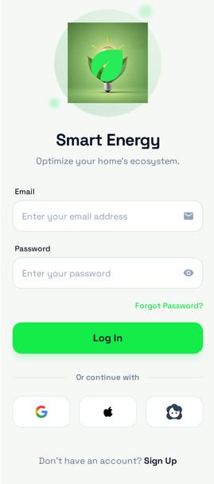
2. User creating Account:
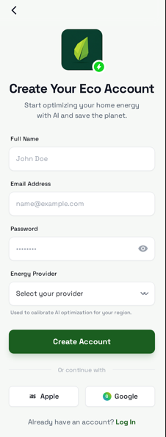
3.Analysing Energy usage and predict Bill:
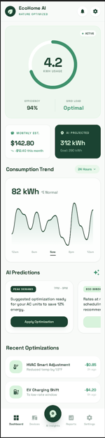
3. The Main Dashboard:
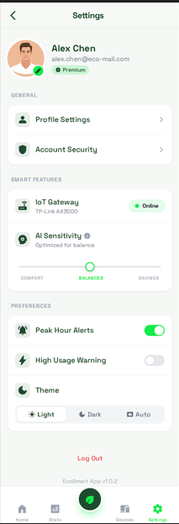

Prototype of Project

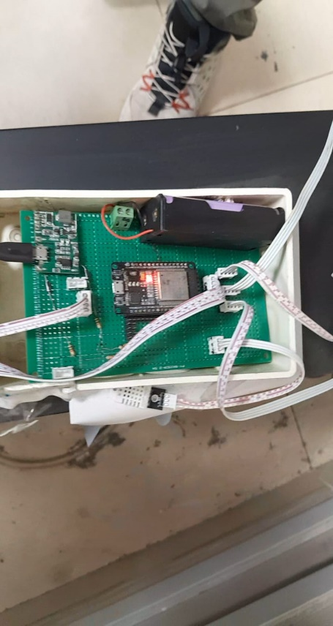
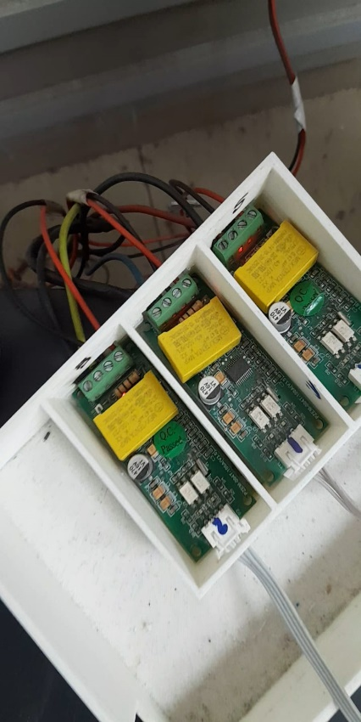

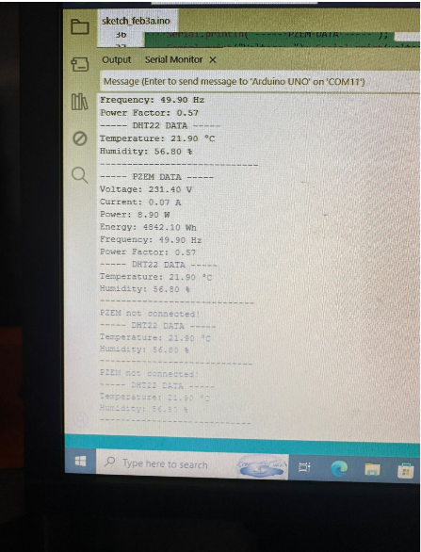

Data flow diagram (optional)

Data Flow Diagram Level 0

Figure 2:DATA FLOW DIAGRAM LEVEL 0

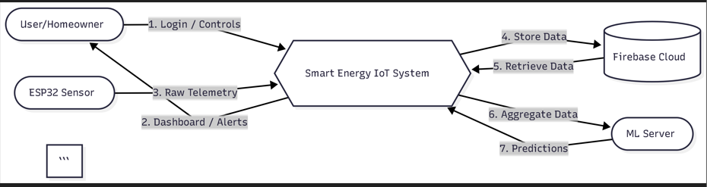

Data Flow Diagram Level 1
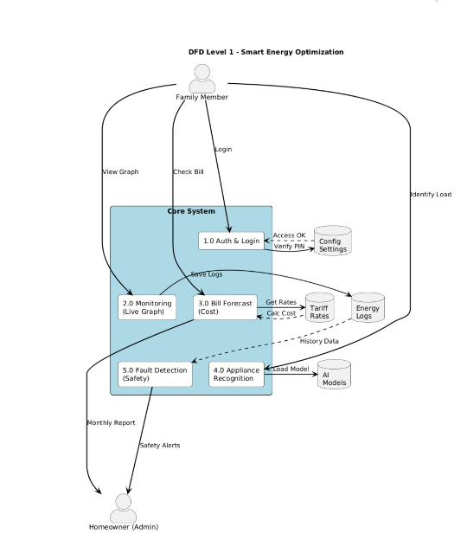

4.3 Data Flow Diagram Level 2

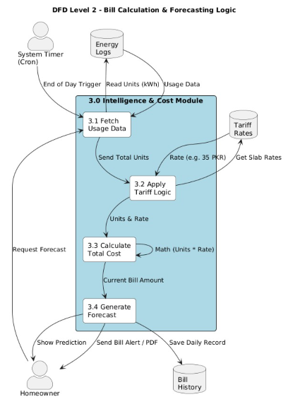

System Design
So this is where we present the blue print. There was a need to think out the way the Smart Energy System thinks before wiring the first sensor. We represented the structure using UML diagrams. It makes us understand how the various components are communicating with one another such as the AI Inference Engine and the Mobile Dashboard. It has been designed around the concept of a decoupled design since we had React Native to make the app, and C++ to make the hardware. It separates the heavy processing and the user interface. The SD Card is on the back, and it contains all the logs, as well as the ESP32 makes all the real-time decisions. The following diagrams indicate how the logic of the wires works.. Below are the diagrams that explain the logic behind the system

System Architecture Diagram

Figure 5:SYSTEM ARCHITECTURE DESIGN
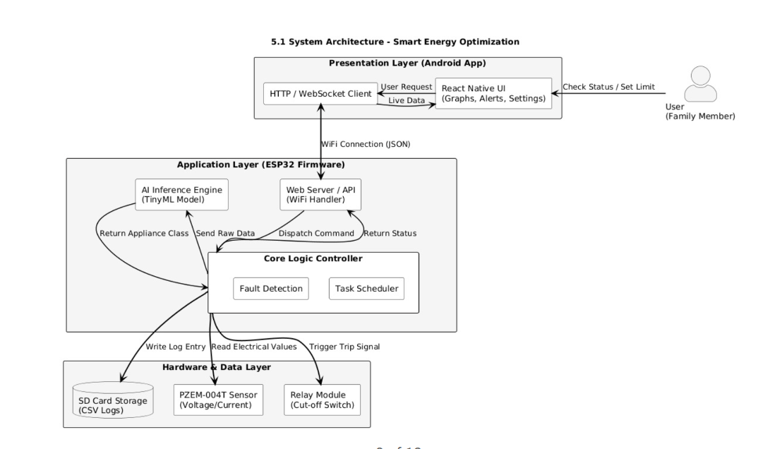

Class Diagram
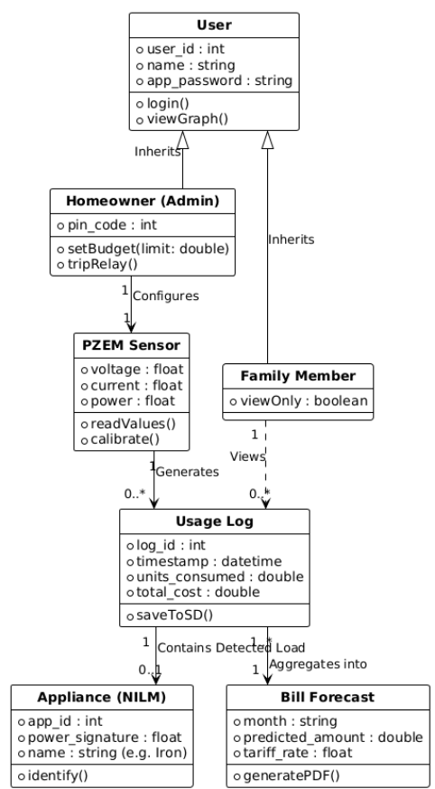
Figure 7:CLASS DIAGRAM

Sequence Diagrams
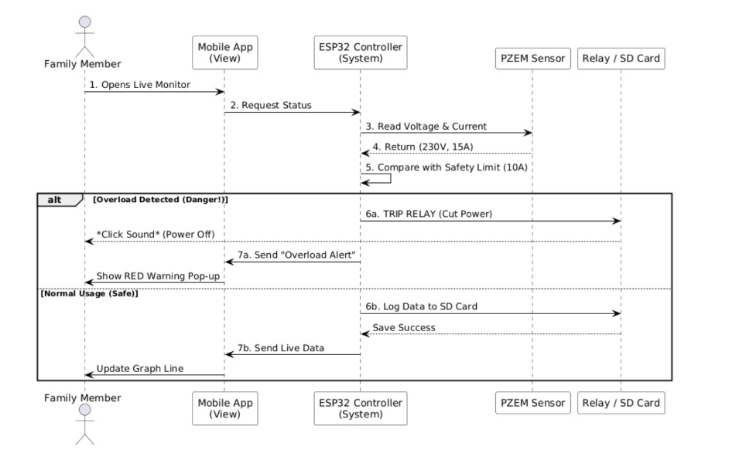
Figure 8:SEQUENCE DIAGRAM

Collaboration Diagrams
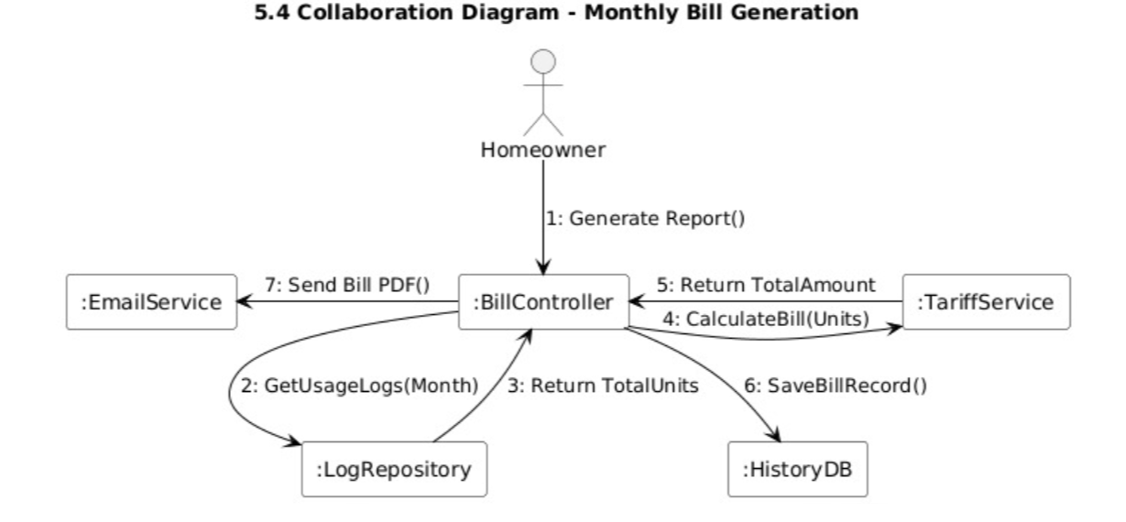
Figure 9:COLLABORATION DIAGRAM

Other UMLs
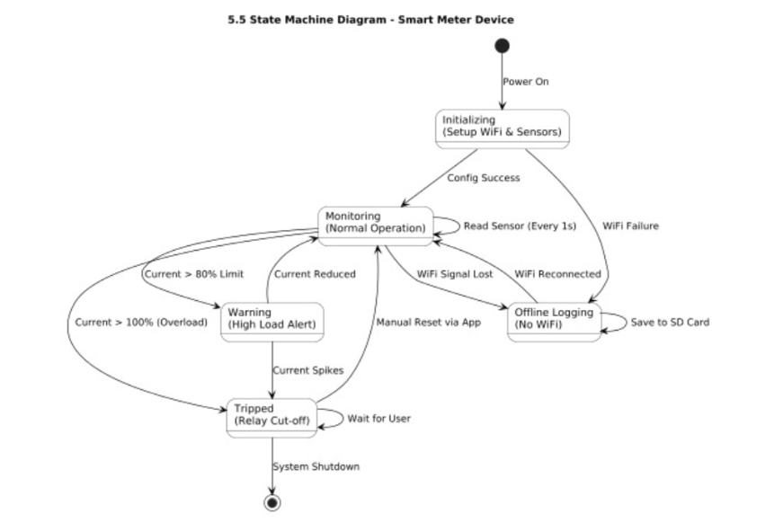
Figure 10: Other UMLs (Sequence Diagram)

ERD
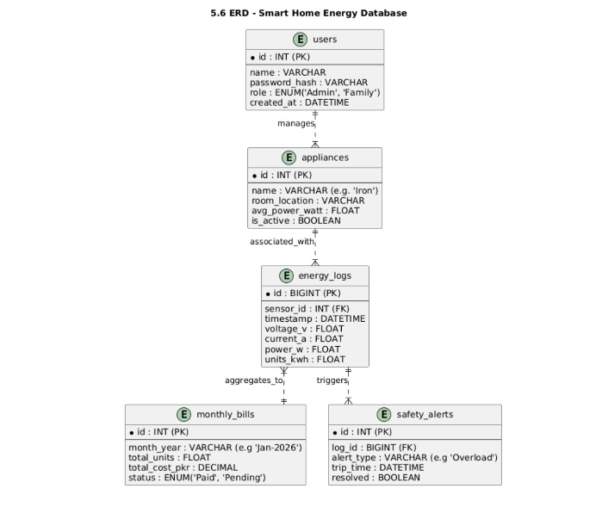
Figure 11:ERD DIAGRAM
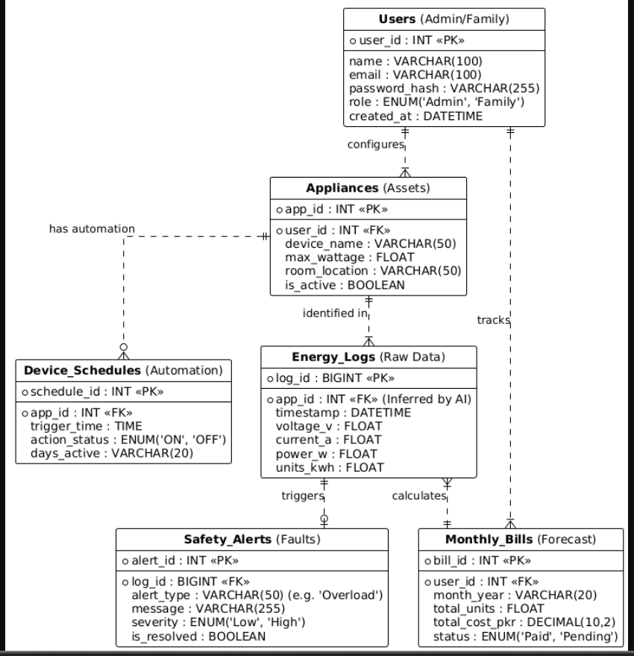
Figure 12:ERD DIAGRAM EXTENDED

Data Dictionary
Here since we have new tables to the Extended ERD so as to accommodate automation and safety are the definitions of the new ones.
Table 04: Device Schedules (Automation Rules)
Field Name | Data Type | Description
Id | INT (PK) | Unique Schedule ID
Appliance-id | INT(FK) | The specific device to control (e.g., AC, Fan).
Trigger-Time | TIME | The specific time to execute the action
Action-Status | ENUM('ON', 'OFF') | What the system should do at that time.

Table no:05 Safety Alerts (System Notifications)
Field Name | Data Type | Description
Id | INT (PK) | Unique Alert ID
Log_id | BIGINT (FK) | Links to the reading that caused the error
Message | VARCHAR(255) | Text shown to user (e.g. "Overload!")
Severity | ENUM('Low', 'High') | How dangerous the event was

Table no :06 Appliances (Asset Config)
Field Name | Data Type | Description
Id | INT(PK) | Unique Device ID
Device-Name | VARCHAR(50) | Name of the asset (e.g. "Bedroom Fan")
Max-Wattage | FLOAT | Power rating used for bill calculation
Room-Location | INT(FK) | Which room the device is installed in

